MariaDB

Tasks

1. Install MariaDB on your Linux system and verify the installation by running the command to check the MariaDB server version.

ANS:

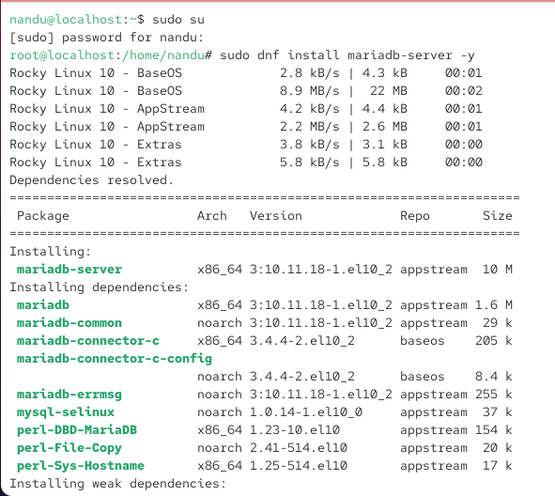

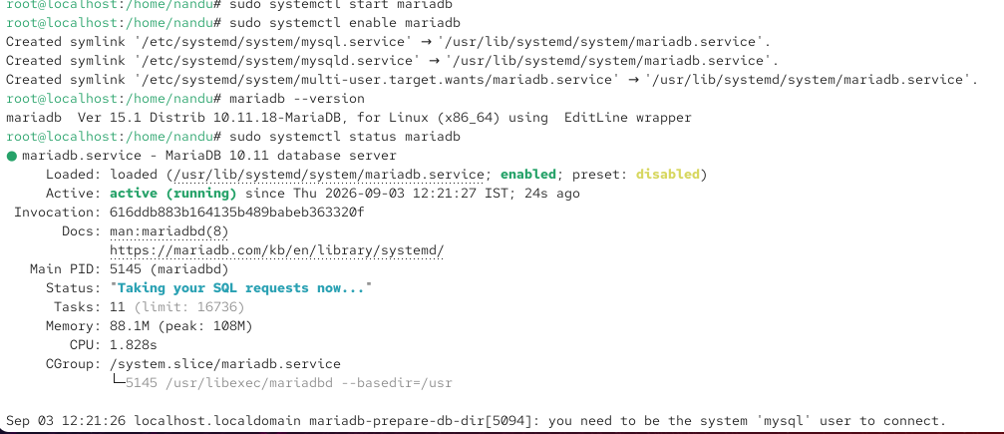

2. Create a new MariaDB database named foodie_app and a table restaurants with columns id (INT, primary key), name (VARCHAR), cuisine (VARCHAR), and rating (FLOAT). Insert 3 sample restaurant records.

ANS:

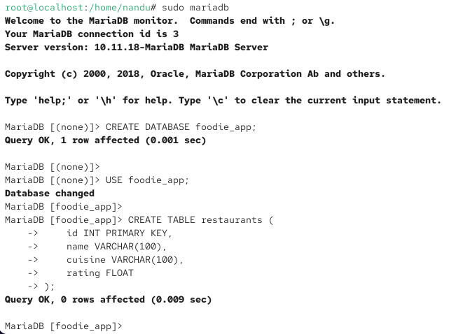

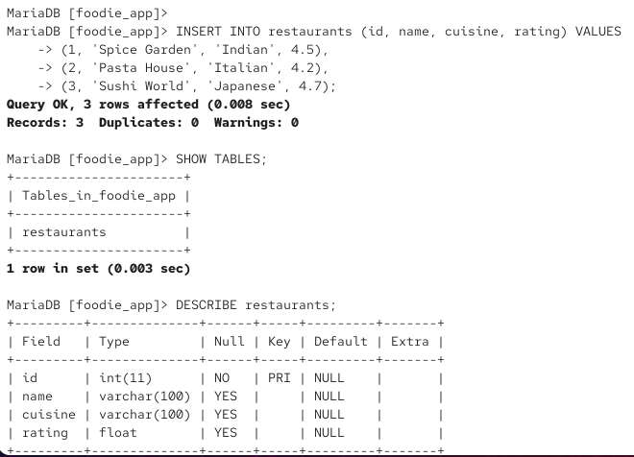

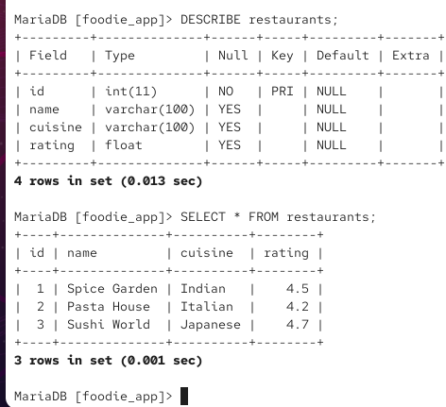

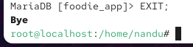

3. Write and execute a SQL query in MariaDB to find all restaurants in the foodie_app database with a rating greater than 4.0 and display their name and cuisine.

ANS:

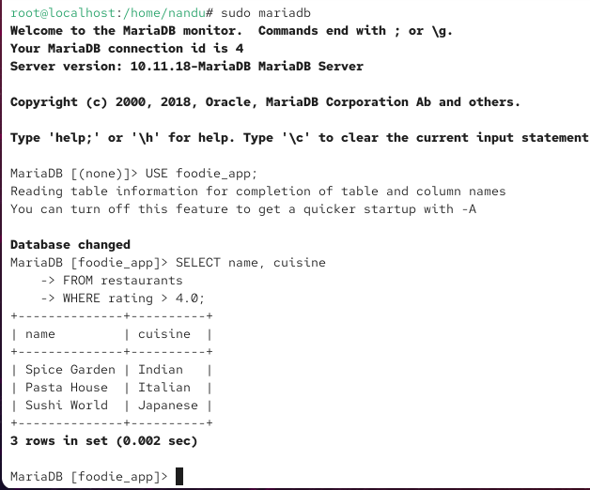

4. Grant SELECT and INSERT permissions on the foodie_app database to a new MariaDB user named zomato_user with password zomato123, then test the permissions by connecting as that user and inserting a new restaurant.

ANS:

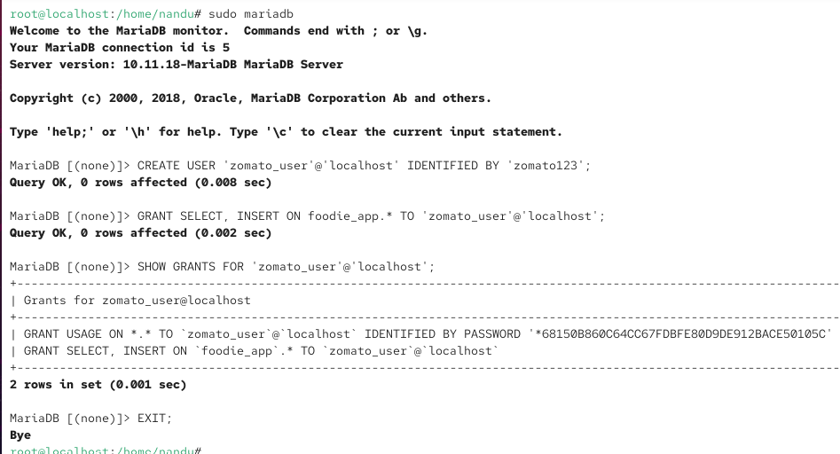

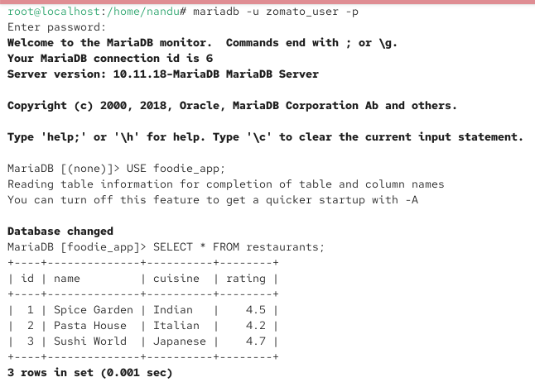

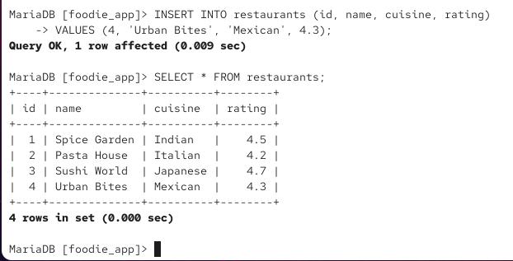

5. Use ChatGPT or Copilot to generate a SQL query that updates the rating of all restaurants with cuisine 'Italian' to 4.5 in your MariaDB table, then run the query and verify the update. Paste your prompt and the AI-generated query in your submission along with the result.

ANS:

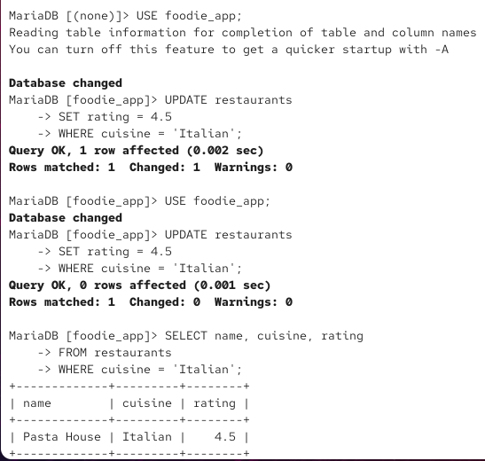

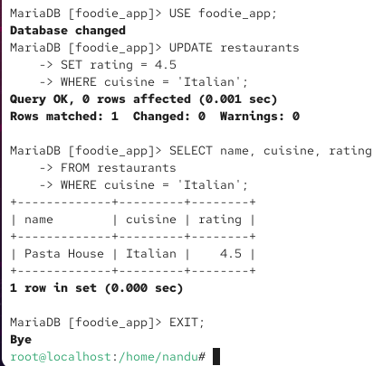

The AI-generated SQL query was executed in MariaDB. The rating of the Italian restaurant was successfully updated to 4.5. The update was verified using a SELECT query, which displayed Bella Italia with a rating of 4.5.

PROMPT:

